**C64 A/V-Adaptor Rev. 1**

**Module Description**

# Introduction

The A/V-Adaptor allows to connect standard S-Video and Audio or Composite-Video cables to the A/V-Jack of the Commodore C64.

A 330Ω resistor to attenuate the Chroma signal for S-Video is installed, but it can be deactivated by setting a jumper (JP2). This attenuation is required, since the chroma signal has a level, which is too high for standard S-Video.

Further, the audio input can be connected to GND, in case it is not in use to reduce the noise introduction.

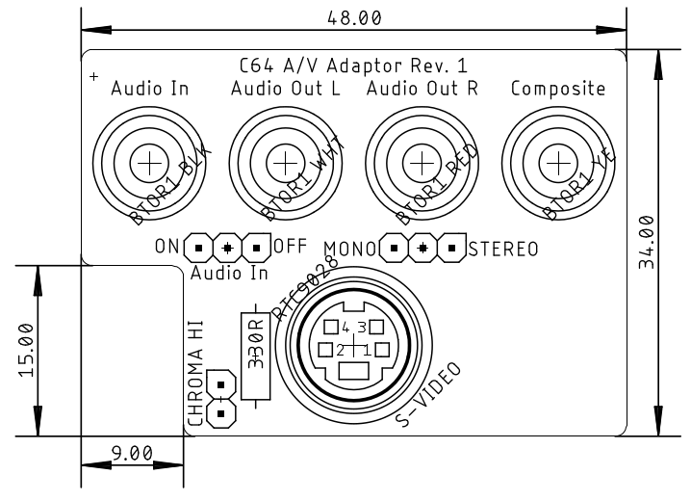

Figure 1: Component side of the A/V-Adaptor

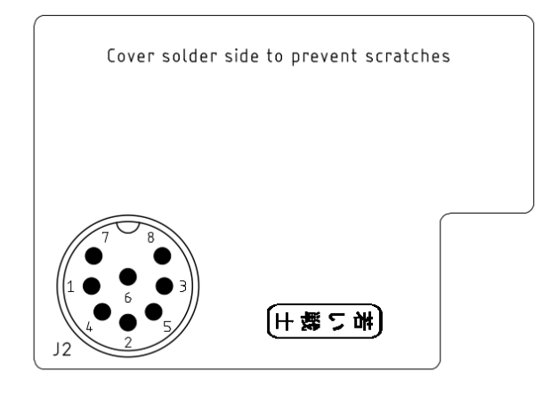

Figure 2: Solder side of the A/V-Adaptor

The two audio output jacks can be connected by a jumper. Alternatively, the stereo sound output (A/V-Jack, pin 7, in case a 2nd SID is installed inside the C64) can be connected to the right channel of the audio output. The first SID output is connected to the left channel of the audio output.

Since the DIN jack for the C64 (J2) has to be installed with a distance, a soldering aid (spacer) is provided with the PCB. It should be clipped off and put between the PCB and J2 while soldering to keep the right distance and angle. After assembly, it can be discarded.

# Connectors

## A/V-Plug – J2

The A/V-Plug for the C64 is the inner part of a Lumberg 033099 SV 80 DIN-Plug (8 pins, horse shoe = 262°). It provides a round plastic shell of the DIN-connector and long enough pins, so the adaptor can sit firmly in the A/V jack. The inner part of a cheaper (standard) connector cannot be used, since it does not sit firm enough.

|  |  |
| --- | --- |
| Pin | Signal |
| 1 | Luminance |
| 2 | GND |
| 3 | Audio Out (mono/left) |
| 4 | Composite Video |
| 5 | Audio In |
| 6 | Chrominance |
| 7 | Audio Out (right – if provided) |
| 8 | - |

## S-Video Jack – J1

A vertical PCB mount Mini-DIN jack (4 circuits)

|  |  |
| --- | --- |
| Pin | Signal |
| 1 | GND (Luminance) |
| 2 | GND (Chrominance) |
| 3 | Luminance |
| 4 | Chrominance |

## RCA-Jacks – J3, J4, J5 & J6

|  |  |
| --- | --- |
| Connector | Signal |
| J3 | Audio Out (mono/left) |
| J4 | Audio Out (mono/right) |
| J5 | Audio In |
| J6 | Composite Video |

# Jumpers

## Chrominance attenuation – JP1

The chrominance signal has a too high level for the standard S-Video chroma signal. The jumper bridges the 330Ω resistor (R1) to switch off this attenuation.

|  |  |
| --- | --- |
| Status | Configuration |
| open | Attenuation active |
| set | Attenuation inactive/off |

## Audio Input Off – JP2

To reduce the noise introduction to the Audio Input, this can be grounded.

|  |  |
| --- | --- |
| Status | Configuration |
| ON | SID Audio In connected to J5 |
| OFF | SID Audio In connected to GND |

## Mono/Stereo – JP3

The standard audio output of the SID is one channel (mono). In cases a 2nd SID is installed, the 2nd audio output is (usually) connected to Pin 7 of the Audio/Video jack of the C64. JP3 connected the right channel of the audio output (J4) to either J2, Pin 3 or Pin 7.

|  |  |
| --- | --- |
| Status | Configuration |
| MONO | J4 connected to J2, Pin 3 |
| STEREO | J4 connected to J2, Pin 7 |

# Assembly

Install the DIN plug (J2) on the solder side (bottom) first. Put the PCB on a suitable surface, the solder side up. Insert the DIN-plug, make sure, it is vertical and solder one pin first (from the solder side, which is pointing up, refer to Figure 3). Check again that the plug is straight, correct if required and finally solder all other pins.

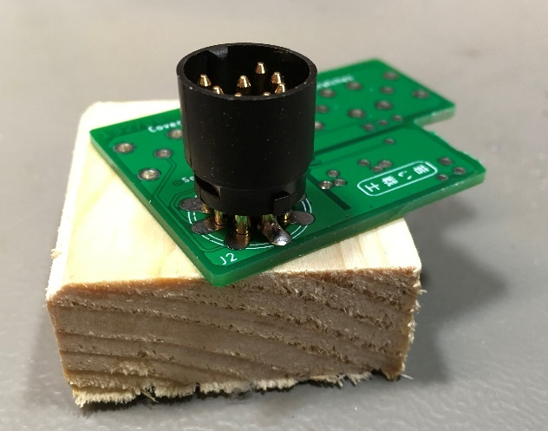

Figure 3: Soldering the DIN-plug J2

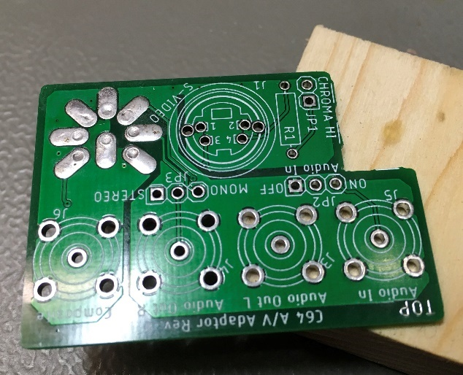

Figure 4: DIN-plug seen from the component side ("TOP")

Install and solder all other components from the component side. Watch the angle of the components, solder them from the solder side. Clip excess pin length.

In case no enclosure is used, cover the solder side (except J2) with duct tape to prevent scratching the case of the C64.

# Versions for the ASSY 326298 (5-pin) and the VIC-20

ASSY 326298 was the first model of the C64, which was built in 1982. It did not have all S-Video signals. Chroma is missing. Thus, a 5-pin DIN plug is required for J2. The S-Video jack (J1) is not required.

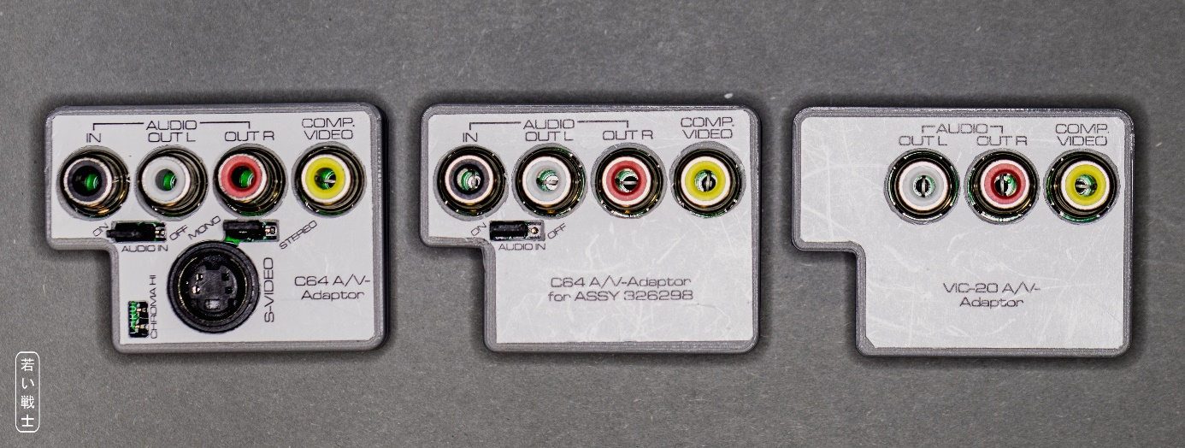

Figure 5: The three models of the A/V-Adaptor

The VIC-20 also requires a 5-pin DIN plug but no Audio-in RCA jack.

|  |  |  |  |
| --- | --- | --- | --- |
| Component | C64 regular | C64 ASSY326298 | VIC-20 |
| J2 (DIN) | SV 80 (8 pin) | SV 50 (5 pin) | SV 50 (5 pin) |
| J1 (S-Video) | populate | do not populate | do not populate |
| J5 (RCA: Audio in) | populate | populate | do not populate |
| JP1 (Chroma 330Ω) | populate | do not populate | do not populate |
| JP2 (Audio In) | populate | populate | do not populate |
| JP3 (mono/stereo) | populate | hardwire to mono | hardwire to mono |
| R1 (330Ω) | populate | do not populate | do not populate |

SV 80 and SV 50 are Lumberg components.

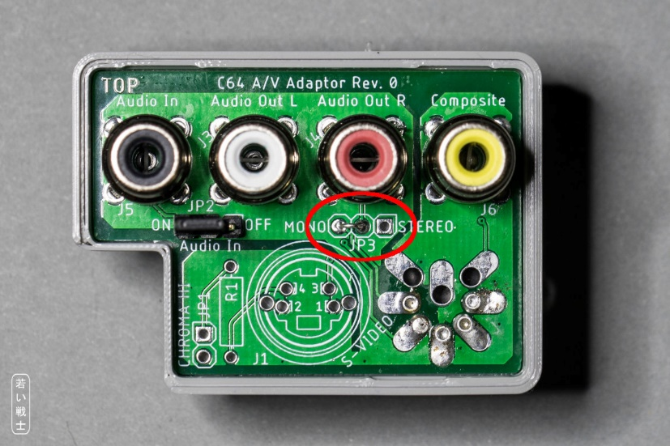

Figure 6: JP3 hardwired to mono

JP3 can be hardwired using a short piece of wire.

# Revision History

## Rev. 0 → Rev. 1

Spacer was removed from the design.